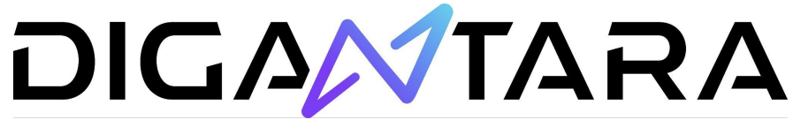

**Conjunction Analysis**

**A) Analyzing data for the date “8-11-2023”:**

**Indicators:** From Figure 1 we can see that there were a total of 6240 conjunctions for the date "8-11-2023" with an average speed of 11.44 km/hr and an average range of 3.34 km.



**Top 10 common objects involved in conjunctions (Active VS Inactive):** From Figure 2, we can AAUSAT-II[P] (18), OBJECT A[+] (18), HIBER-2 [+] (16), ITASAT[+] (16), LEMUR-2-KADI[+](15), OBJECT C[+](15), QB50P1[+] (14), CARTOSAT-2D[+] (13), CS2[+] (13), D-STAR ONE(SPARROW)[+] (13) and PROMETHEUS 2-3 [+] are the top 10 active objects commonly involved in conjunction.



From Figure 3 we can see that out of a total of 6,240 conjunction scenarios FENGYUN 1C DEB[-] has been involved in 485 (7.772%) conjunctions followed by COSMOS 2251 DEB[-] 295 (4.728%).

**Max Probability of Collision:** Figure 4, shows the distribution of probability over time. The object with the maximum probability of collision (MAX_PROB) is 0.01477 which took place between Norad Catalog ID 43805 (Object Name 1: AL-FARABI 2 [+]) and NORAD Catalog ID 55498 (OBJECT_NAME_2: STARLINK-5365 [+]) and it took place at 6:55:40 PM. 

**B) Analyzing data for object “STELLA [+]”:**

**Indicators:** Over the past seven days, STELLA [+] has been involved in 19 conjunctions, with an average distance of 3.63 km and an average speed of 9.08 km/hr. The DSE_1 of this object is 3.72 days, while the DSE_2 is 4.32 days with other objects.



**Top 10 objects involved in conjunction with “STELLA [+]”:** Out of the 19 objects involved in conjunction with “STELLA [+]” FENGYUN 1C DEB [-] has been involved in 7 (36.84%) conjunctions followed by NOAA 16 DEB [-] having 4 (21.05%) conjunctions.

**Max Probability of Collision:** The figure shows the distribution of probability over time for "STELLA [+]" where the maximum probability of collision (MAX_PROB) is 0.0000008528. This collision took place on 12th November 2023 at 8:41:08 p.m. with NORAD Catalog ID 25159 (OBJECT_NAME_2: ORBCOMM FM04 [+]).



**C) Analysis of the entire dataset:**

**Indicators:** In figure 8, it can be seen that there were in total 66,954 conjunctions from 11/8/2023 to 11/15/2023 with an average speed of 11.38 km/hr, range of 3.33 km, and DSE_1 and DSE_2 of 3.99 days and 4.38 days, respectively.



**Top 10 objects involved in conjunction:** Figure 9 shows the top 10 active objects involved in conjunctions with Object A[+] 160 (0.24%) having the highest number of involvements followed by Object C 155 (0.23%) and AAUSAT-II [P] 138 (0.21%).

From figure 10, we can see that FENGYUN 1C DEC[-] has had the highest involvement of 5393 (8.055%) conjunctions, followed by COSMOS 2251 DEB [-] 3118 (4.657%). 

**Probability of collision over time:** From figure 11, we can see that the max probability of collision is 0.2182 which took place between Norad Cat Id 1 (Object Name 1: STARLINK-4528[+]) and Norad Cat Id 2 (Object Name 2: ARIANE 40+3 R/B [-]) 

**STARLINK-4528[+]:** Over the 7 days STARLINK-4528[+] has been involved in 10 conjunctions majority with STARLINK-5231 [P] 2(20%) and has had an average speed of 11.4 km/hr and an average range of 3.19 km.

**Conclusion:** Furthermore, this dataset can be analyzed further by examining correlations between variables, calculating average TCAs for all conjunctions so as to determine when close encounters generally occur during the day, or detecting outliers that may indicate anomalies in the data or significant changes in the accuracy of the data.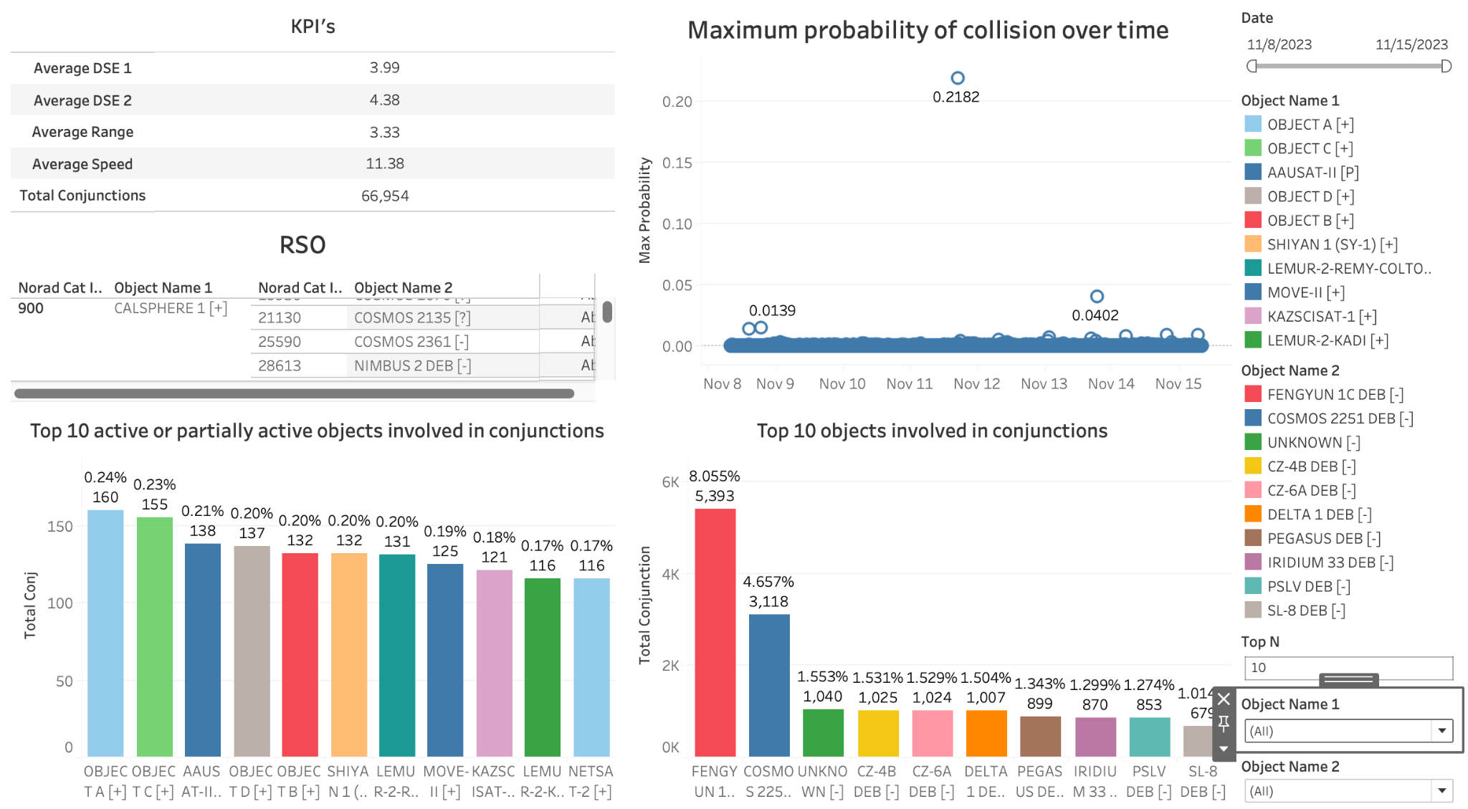

**Dashboard:**